

《 人工智能 》
实验报告本

班 级： | 计211
学 号： | 21013025
姓 名： | 单楚雄
指导教师： | 陈志华

信息科学与工程学院
年 月

《人工智能》实 验 报 告
实验2名称：模糊推理系统实验 | 实验地点：信息楼215
所使用的工具软件及环境：
Python版本：Python 3及以上
一、实验目的

理解模糊逻辑推理的原理及特点，熟练应用模糊推理，了解可能性理论。
二、实验原理
模糊推理所处理的事物自身是模糊的，概念本身没有明确的外延，一个对象是否符合这个概念难以明确地确定模糊推理是对这种不确定性，即模糊性的表示与处理。模糊逻辑推理是基于模糊性知识(模糊规则)的一种近似推理，一般采用Zadeh提出的语言变量、语言值、模糊集和模糊关系合成的方法进行推理。
三、实验要求
设计洗衣机洗涤时间的模糊控制。已知人的操作经验为：
“污泥越多，油脂越多，洗涤时间越长”；
“污泥适中，油脂适中，洗涤时间适中”；
“污泥越少，油脂越少，洗涤时间越短”。
要求：
（1）设计相应的模糊控制器，给出输入、输出语言变量的隶属函数图，模糊控制规则表和推论结果立体图。
（2）自己假定当前传感器测得的信息（污泥与油脂），进行洗衣机的模糊推理。
提示：如图1。其中SD（污泥少）、MD（污泥中）、LD（污泥多）、NG（油脂少）、MG（油脂中）、LG（油脂多）、VS（洗涤时间很短）、S（洗涤时间短）、M（洗涤时间中等）、L（洗涤时间长）、VL（洗涤时间很长）。
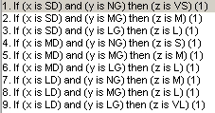
图1 模糊控制规则
- 实验步骤
模糊控制规则如表1所示：
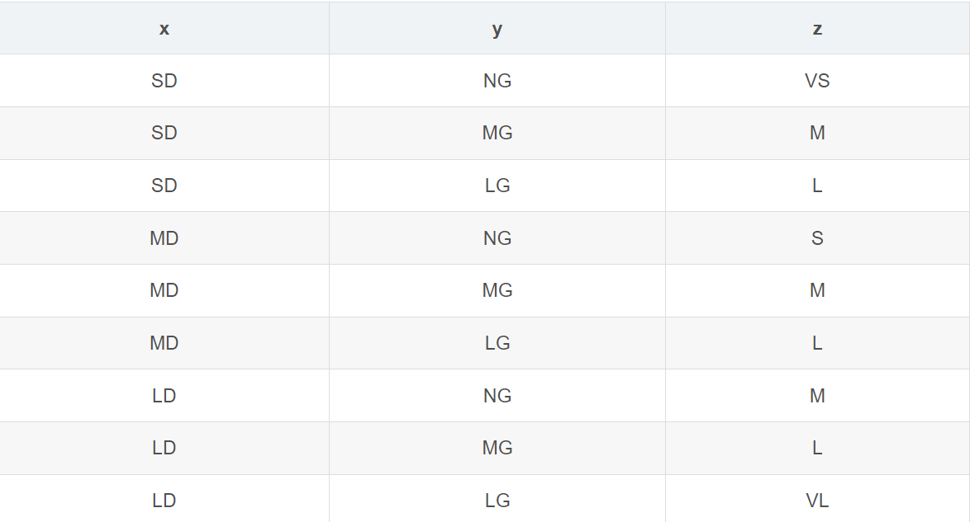
其中：
SD(污泥少)、MD(污泥中)、LD(污泥多)、NG(油脂少)、MG(油脂中)、LG(油脂多)、VS(洗涤时间很短)、S(洗涤时间短)、M(洗涤时间中等)、L(洗涤时间长)、VL(洗涤时间很长)。

污泥隶属函数：
sludge['SD'] = fuzz.trimf(sludge.universe, [0, 0, 50])
sludge['MD'] = fuzz.trimf(sludge.universe, [0, 50, 100])
sludge['LD'] = fuzz.trimf(sludge.universe, [50, 100, 100])
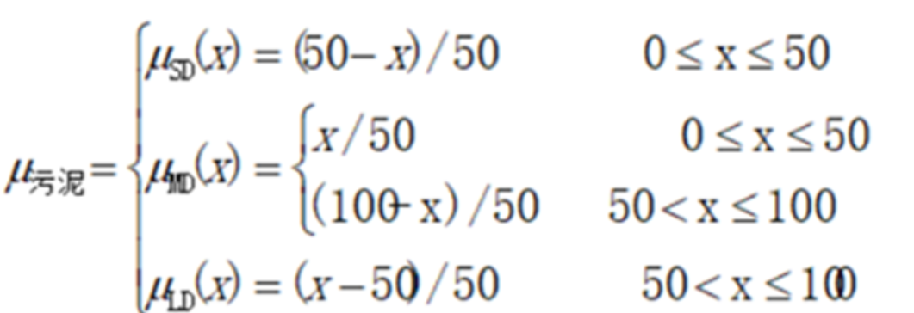
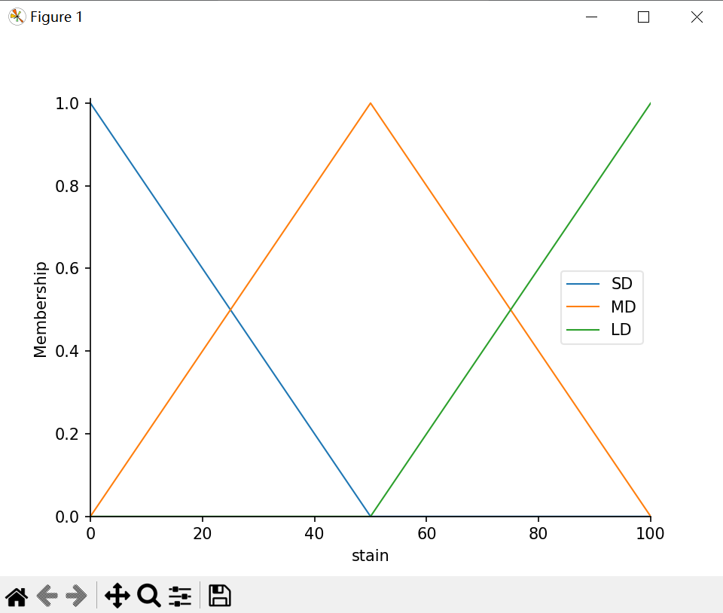
油脂隶属函数：
grease['NG'] = fuzz.trimf(grease.universe, [0, 0, 50])
grease['MG'] = fuzz.trimf(grease.universe, [0, 50, 100])
grease['LG'] = fuzz.trimf(grease.universe, [50, 100, 100])
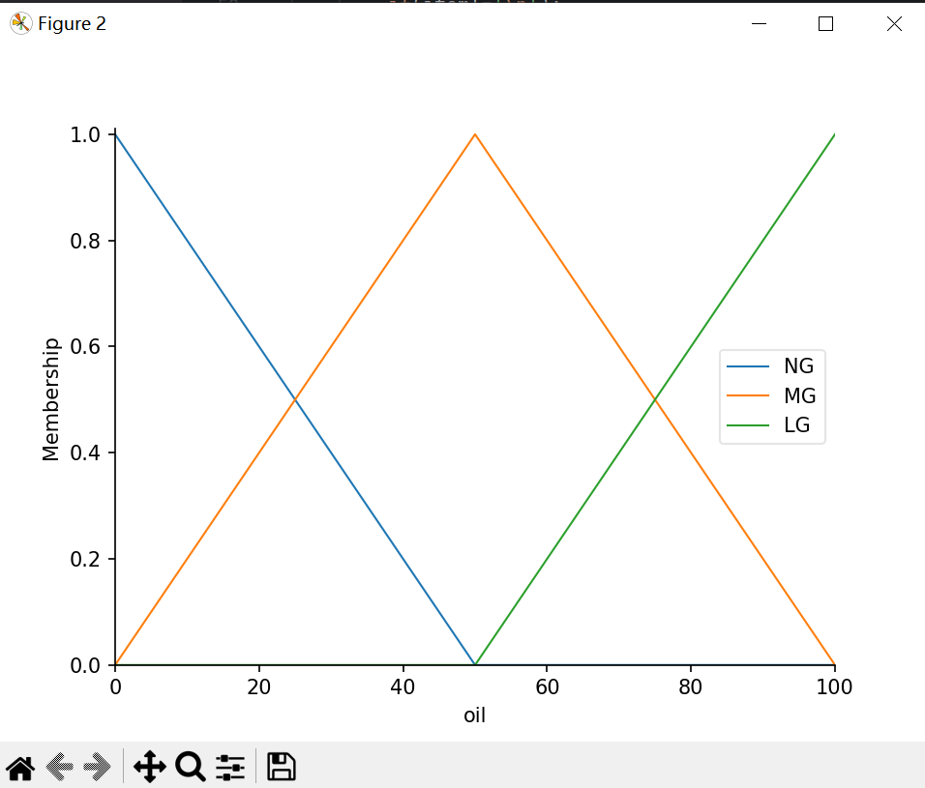
洗涤时间隶属度函数：
washing_time['VS'] = fuzz.trimf(washing_time.universe, [0, 0, 30])
washing_time['S'] = fuzz.trimf(washing_time.universe, [0, 30, 60])
washing_time['M'] = fuzz.trimf(washing_time.universe, [30, 60, 90])
washing_time['L'] = fuzz.trimf(washing_time.universe, [60, 90, 120])
washing_time['VL'] = fuzz.trimf(washing_time.universe, [90, 120, 120])

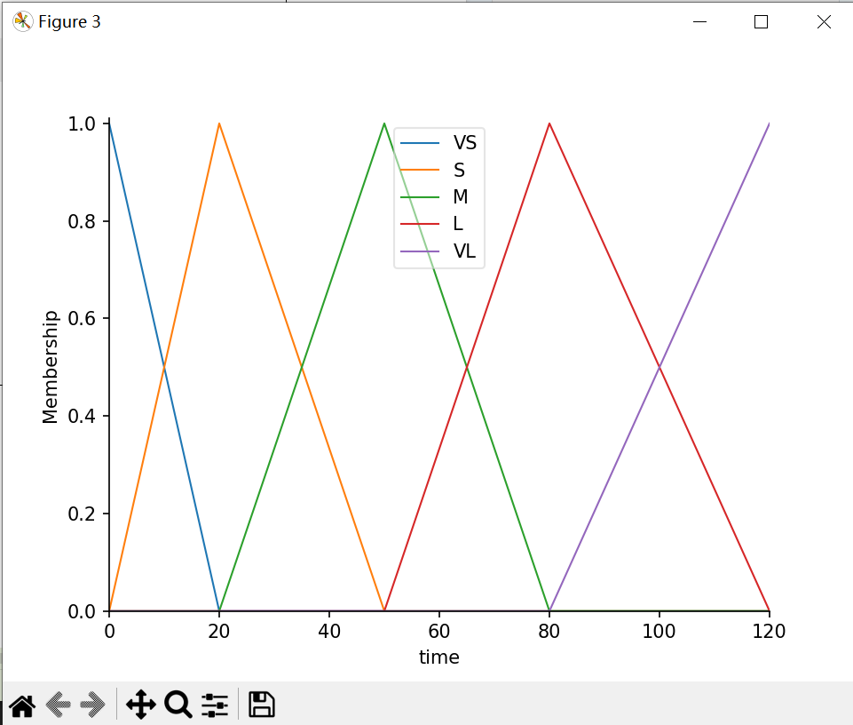

模糊控制规则表：
SD（污泥少）、MD（污泥中）、LD（污泥多）、
NG（油脂少）、MG（油脂中）、LG（油脂多）、VS（洗涤时间很短）、
S（洗涤时间短）、M（洗涤时间中等）、L（洗涤时间长）、VL（洗涤时间很长）。
推论结果立体图：

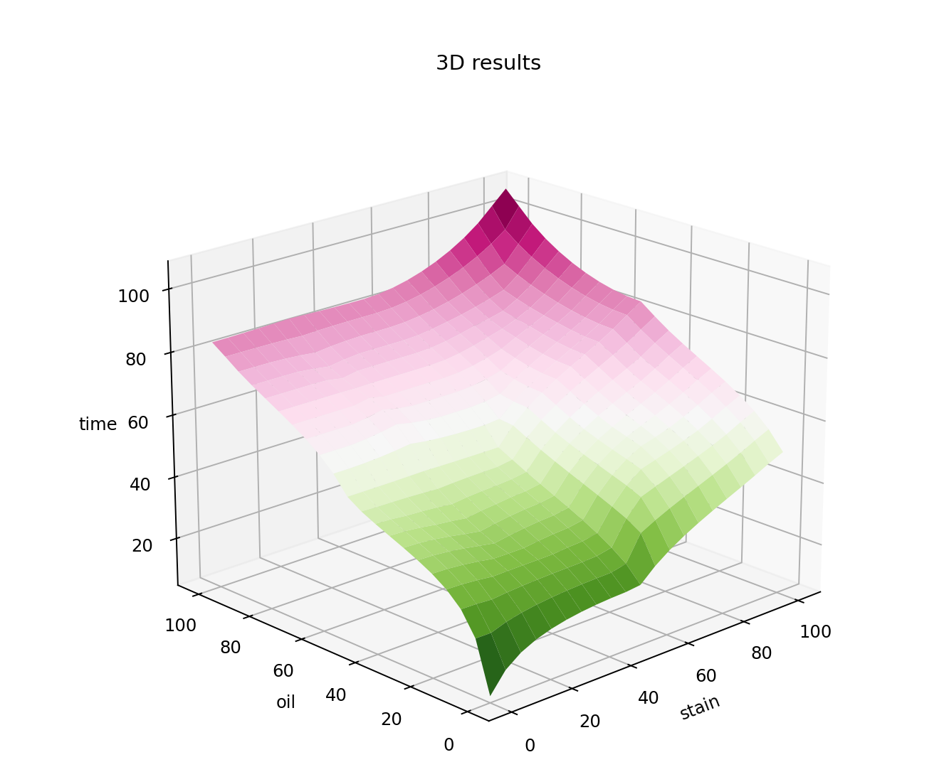
假定当前传感器测得的信息为x0(污泥)=60，y0(油脂)=70，采用模糊决策，给出模糊推理结果，并观察模糊推理的动态仿真环境，给出其动态仿真环境图：

模糊匹配
（1） 模糊匹配
将x=60,y=70带入的隶属度函数中：
（2）规则触发。被触发的规则有4条：
Rule1:IF x is MD AND y is MG THEN z is M;
Rule2:IF x is MD AND y is LG THEN z is L;
Rule3:IF x is LD AND y is MG THEN z is L;
Rule4:IF x is LD AND y is LG THEN z is VL。
（3）规则前提推理。在同一条规则内，前提之间通过交运算得到规则结论。
（4）模糊系统总的输出（聚合）,取各条规则推理结果的并。
（5）去模糊化。采用加权平均判决发的方法。根据洗涤时间隶属函数的反函数用相应的隶属度求出时间论域中对应的值。
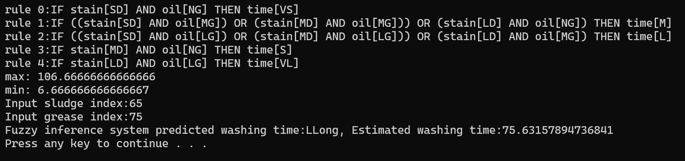
- 程序设计的核心代码
#!/usr/bin/python
# -*- coding: UTF-8 -*-
import numpy as np
import skfuzzy as fuzz
import matplotlib
matplotlib.use('TkAgg')
import matplotlib.pyplot as plt
from skfuzzy import control as ctrl

# Define input and output ranges
# Sludge and grease ranges are [0, 100]
# Washing time range is [0, 120]
x_stain = np.arange(0, 101, 1)
x_oil = np.arange(0, 101, 1)
x_time = np.arange(0, 121, 1)
# Define fuzzy control variables
stain = ctrl.Antecedent(x_stain, 'stain')
oil = ctrl.Antecedent(x_oil, 'oil')
time = ctrl.Consequent(x_time, 'time')
# Generate fuzzy membership functions
stain['SD'] = fuzz.trimf(x_stain, [0, 0, 50])
stain['MD'] = fuzz.trimf(x_stain, [0, 50, 100])
stain['LD'] = fuzz.trimf(x_stain, [50, 100, 100])
oil['NG'] = fuzz.trimf(x_oil, [0, 0, 50])
oil['MG'] = fuzz.trimf(x_oil, [0, 50, 100])
oil['LG'] = fuzz.trimf(x_oil, [50, 100, 100])
time['VS'] = fuzz.trimf(x_time, [0, 0, 20])
time['S'] = fuzz.trimf(x_time, [0, 20, 50])
time['M'] = fuzz.trimf(x_time, [20, 50, 80])
time['L'] = fuzz.trimf(x_time, [50, 80, 120])
time['VL'] = fuzz.trimf(x_time, [80, 120, 120])

# Use centroid defuzzification method
time.defuzzify_method = 'centroid'

# Rules
rule1 = ctrl.Rule(antecedent=((stain['SD'] & oil['NG'])), consequent=time['VS'], label='time=VS')
rule2 = ctrl.Rule(antecedent=((stain['SD'] & oil['MG'])|(stain['MD'] & oil['MG'])|(stain['LD'] & oil['NG'])), consequent=time['M'], label='time=M')
rule3 = ctrl.Rule(antecedent=((stain['SD'] & oil['LG'])|(stain['MD'] & oil['LG'])|(stain['LD'] & oil['MG'])), consequent=time['L'], label='time=L')
rule4 = ctrl.Rule(antecedent=((stain['MD'] & oil['NG'])), consequent=time['S'], label='time=S')
rule5 = ctrl.Rule(antecedent=((stain['LD'] & oil['LG'])), consequent=time['VL'], label='time=VL')

# System and runtime environment initialization
rule = [rule1, rule2, rule3, rule4, rule5]
time_ctrl = ctrl.ControlSystem(rule)
wash_time = ctrl.ControlSystemSimulation(time_ctrl)
# Handle some strange characters in the rules and output
for i in range(len(rule)):
print("rule",i,end=":")
for item in str(rule[i]):
if(item!='\n'):
print(item,end="")
else:
break
print('\t')
# Plot
stain.view()
oil.view()
time.view()
plt.show()
# Plot 3D graph
upsampled = np.linspace(0, 101, 21)
x, y = np.meshgrid(upsampled, upsampled)
z = np.zeros_like(x)
pp = []
for i in range(0, 21):
for j in range(0, 21):
wash_time.input['stain'] = x[i, j]
wash_time.input['oil'] = y[i, j]
wash_time.compute()
z[i, j] = wash_time.output['time']
pp.append(z[i, j])
print('max:', max(pp))
print('min:', min(pp))
from mpl_toolkits.mplot3d import Axes3D
fig = plt.figure(figsize=(8, 8))
ax = fig.add_subplot(111, projection='3d')
surf = ax.plot_surface(x, y, z, rstride=1, cstride=1, cmap='PiYG_r', linewidth=0.1, antialiased=True)
ax.view_init(20, 270)
plt.title('3D results')
ax.set_xlabel('stain')
ax.set_ylabel('oil')
ax.set_zlabel('time')
plt.show()

import numpy as np
import matplotlib.pyplot as plt
from matplotlib.animation import FuncAnimation

# Import NumPy for mathematical operations
import numpy as np

# Add input value checking in the Sludge and Grease functions
def Sludge(a):
sludge = [0, 0, 0]
if a < 0:
a = 0
elif a > 100:
a = 100
if 0 <= a <= 50:
sludge[0] = (50 - a) / 50
sludge[1] = a / 50
elif 50 < a <= 100:
sludge[1] = (100 - a) / 50
sludge[2] = (a - 50) / 50
return sludge

def Grease(a):
grease = [0, 0, 0]
if a < 0:
a = 0
elif a > 100:
a = 100
if 0 <= a <= 50:
grease[0] = (50 - a) / 50
grease[1] = a / 50
elif 50 < a <= 100:
grease[1] = (100 - a) / 50
grease[2] = (a - 50) / 50
return grease

# Rule premise reasoning and taking the minimum value
def Rules(a, b):
rules_value = [0, 0, 0, 0, 0, 0, 0, 0, 0]
if a[0] != 0 and b[0] != 0:
rules_value[0] = min(a[0], b[0])
if a[0] != 0 and b[1] != 0:
rules_value[1] = min(a[0], b[1])
if a[0] != 0 and b[2] != 0:
rules_value[2] = min(a[0], b[2])
if a[1] != 0 and b[0] != 0:
rules_value[3] = min(a[1], b[0])
if a[1] != 0 and b[1] != 0:
rules_value[4] = min(a[1], b[1])
if a[1] != 0 and b[2] != 0:
rules_value[5] = min(a[1], b[2])
if a[2] != 0 and b[0] != 0:
rules_value[6] = min(a[2], b[0])
if a[2] != 0 and b[1] != 0:
rules_value[7] = min(a[2], b[1])
if a[2] != 0 and b[2] != 0:
rules_value[8] = min(a[2], b[2])
return rules_value

# Create a list of time steps
time_steps = np.arange(0, 100, 1)

# List to store fuzzy output values
output_values = []

# Create an initial sensor input
x0 = 60
y0 = 70

# Simulate fuzzy inference process
for t in time_steps:
x = x0
y = y0
sludge_membership = Sludge(x)
grease_membership = Grease(y)
rule_results = Rules(sludge_membership, grease_membership)
final_output = max(rule_results)
output_values.append(final_output)
x0 += 1
y0 += 1

# Create a graph window
fig, ax = plt.subplots()

# Set initial graph
line, = ax.plot([], [])
ax.set_xlim(0, len(time_steps))
ax.set_ylim(0, 1)
ax.set_xlabel("Time Step")
ax.set_ylabel("Fuzzy Output")
ax.set_title("Fuzzy Logic Control Simulation")

# Update function
def update(frame):
line.set_data(time_steps[:frame + 1], output_values[:frame + 1])
return line,

# Create animation
ani = FuncAnimation(fig, update, frames=len(time_steps), blit=True, repeat=False)
plt.show()

# 1. Sludge membership calculation
def Sludge(a):
sludge = [0, 0, 0]
if a < 0 or a > 100:
return (print("Input value error"))
elif 0 <= a <= 50:
sludge[0] = (50 - a) / 50
sludge[1] = a / 50
elif 50 < a <= 100:
sludge[1] = (100 - a) / 50
sludge[2] = (a - 50) / 50
return sludge

# 2. Grease membership calculation
def Grease(a):
grease = [0, 0, 0]
if a < 0 or a > 100:
return (print("Input value error"))
elif 0 <= a <= 50:
grease[0] = (50 - a) / 50
grease[1] = a / 50
elif 50 < a <= 100:
grease[1] = (100 - a) / 50
grease[2] = (a - 50) / 50
return grease

# 3. Rule premise reasoning and taking the minimum value
def Rules(a, b):
rules_value = [0, 0, 0, 0, 0, 0, 0, 0, 0]
if a[0] != 0 and b[0] != 0:
rules_value[0] = min(a[0], b[0])
if a[0] != 0 and b[1] != 0:
rules_value[1] = min(a[0], b[1])
if a[0] != 0 and b[2] != 0:
rules_value[2] = min(a[0], b[2])
if a[1] != 0 and b[0] != 0:
rules_value[3] = min(a[1], b[0])
if a[1] != 0 and b[1] != 0:
rules_value[4] = min(a[1], b[1])
if a[1] != 0 and b[2] != 0:
rules_value[5] = min(a[1], b[2])
if a[2] != 0 and b[0] != 0:
rules_value[6] = min(a[2], b[0])
if a[2] != 0 and b[1] != 0:
rules_value[7] = min(a[2], b[1])
if a[2] != 0 and b[2] != 0:
rules_value[8] = min(a[2], b[2])
return rules_value

# 4. Inference of each rule output
def Inference(a):
time_level = [0, 0, 0, 0, 0]
time_level[0] = a[0]
time_level[1] = a[3]
if (a[1] != 0 or a[4] != 0 or a[6] != 0):
list_1 = [a[1], a[4], a[6]]
for i in range(len(list_1) - 1, -1, -1):
if list_1[i] == 0:
list_1.remove(0)
time_level[2] = min(list_1)
if (a[2] != 0 or a[5] != 0 or a[7] != 0):
list_2 = [a[2], a[5], a[7]]
for i in range(len(list_2) - 1, -1, -1):
if list_2[i] == 0:
list_2.remove(0)
time_level[3] = min(list_2)
time_level[4] = a[8]
return time_level

# 5. According to the weighted average decision method, use the corresponding membership degree to obtain the corresponding value in the time domain according to the inverse function of the washing time membership function
def Max_membership(a):
time = [0, 0, 0, 0, 0, 0, 0, 0]
time[0] = 30 - 30 * a[0]
time[1] = 30 * a[1]
time[2] = 60 - 30 * a[1]
time[3] = 30 * a[2] + 30
time[4] = 90 - 30 * a[2]
time[5] = 30 * a[3] + 60
time[6] = 120 - 30 * a[3]
time[7] = 30 * a[4] + 90
sum_1 = time[0] * a[0] + time[1] * a[1] + time[2] * a[1] + time[3] * a[2] + time[4] * a[2] + time[5] * a[3] + time[
6] * a[3] + time[7] * a[4]
sum_2 = a[0] + 2 * a[1] + 2 * a[2] + 2 * a[3] + a[4]
result = sum_1 / sum_2
return result

# Washing time membership function
def WashTime(a):
if 0 <= a <= 30:
u1 = (30 - a) / 30
u2 = a / 30
if (u1 > u2):
time_level = 'VS'
else:
time_level = 'S'
if 30 < a <= 60:
u3 = (60 - a) / 30
u4 = (a - 30) / 30
if (u3 > u4):
time_level = 'S'
else:
time_level = 'M'
if 60 < a <= 90:
u5 = (90 - a) / 30
u6 = (a - 60) / 30
if (u5 > u6):
time_level = 'M'
else:
time_level = 'L'
if 90 < a <= 120:
u7 = (120 - a) / 30
u8 = (a - 90) / 30
if (u7 > u8):
time_level = 'L'
else:
time_level = 'VL'
return time_level

if __name__ == '__main__':
sludge = int(input("Input sludge index:"))
grease = int(input("Input grease index:"))
rules_value = Rules(Sludge(sludge), Grease(grease))
time_level = Inference(rules_value)
time_pre = Max_membership(time_level)
time_sign = WashTime(time_pre)
flag = {'VS': 'Very Short', 'S': 'Short', 'M': 'Medium', 'L': 'Long', 'VL': 'Very Long'}
print("Fuzzy inference system predicted washing time:{}{}, Estimated washing time:{}".format(time_sign,flag[time_sign], time_pre))

六、实验体会
这次的模糊逻辑实验深化了我对模糊控制的理解。通过定义模糊控制变量和隶属函数，以及编写规则和推理过程，我成功地模拟出了洗涤时间的预测。利用模糊控制可以处理现实世界中的模糊问题，比如分析污渍和油脂的混合，这样可以更准确地预测洗涤时间。
在编写代码的过程中，我学会了如何定义隶属函数以及如何利用规则进行推理。调试代码时，我发现对输入值进行合理的检查是非常重要的，可以通过设定输入最大值和最小值范围，来避免出现异常情况并提高系统的稳定性和准确性。
另外，通过绘制2D和3D图表，我可以直观地看到模糊控制系统的运行结果，这有助于我更好地理解系统的工作原理和输出情况。总的来说，这次实验让我对模糊逻辑控制有了更深入的认识，并且提高了我的编程和系统建模能力。

七、教师评语

该学生 完成了实验任务，算法设计 ，实验结果 ，实验体会 。
因此总体评价为 。

教师签字：
年 月 日

